SpringBoard Instructions for First-time Login

To access the SpringBoard online textbook, you must use Clever, an app management system.
Step One: Go to https://clever.com/in/cobb . You should see a login screen where you will enter your student number for BOTH the username and the password. When prompted, you must change your password. Create your password following this formula: capital first initial, capital last initial, @symbol, lunch number.
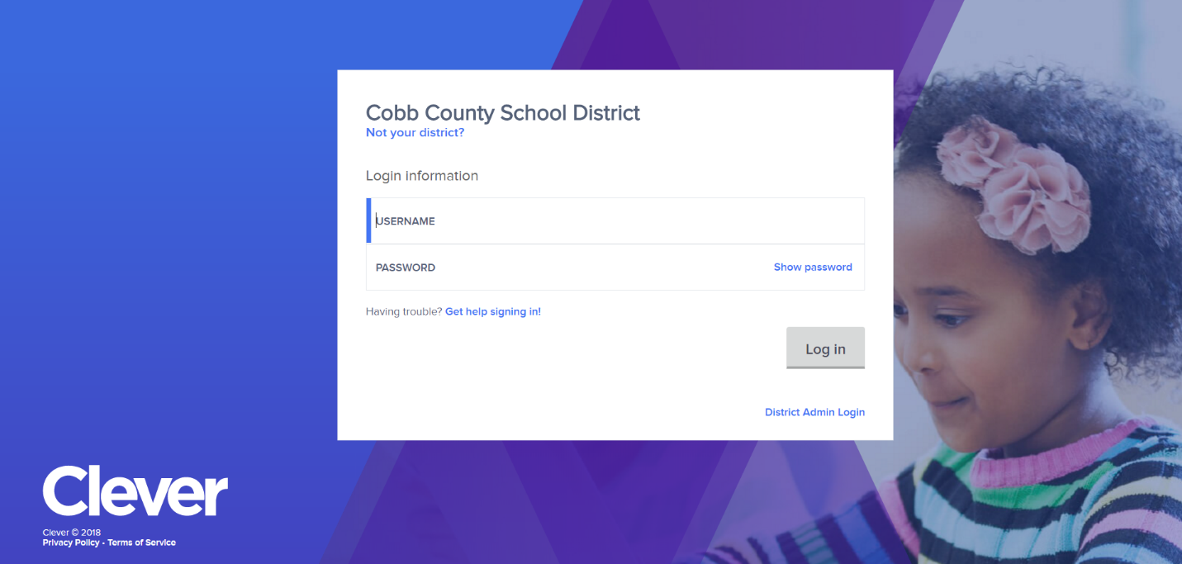
- Example ST@12354

Use your student number for both the username and password the first time you login. Follow the guidelines for setting a new password.

Step Two: Once you change your password, you should see a screen with the SpringBoard icon. Click on it, and you will see a welcome screen that prompts you to create a new password. USE THE SAME PASSWORD YOU JUST CREATED. Next time you access SpringBoard, you should only have to enter the password once when you go to the Clever site.
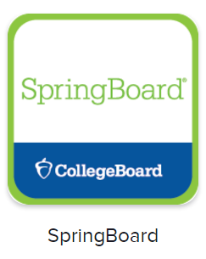
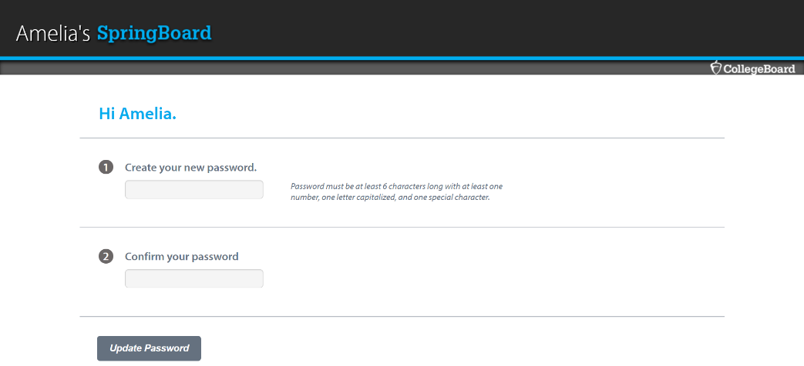
Hi Rachael
Rachael’s

